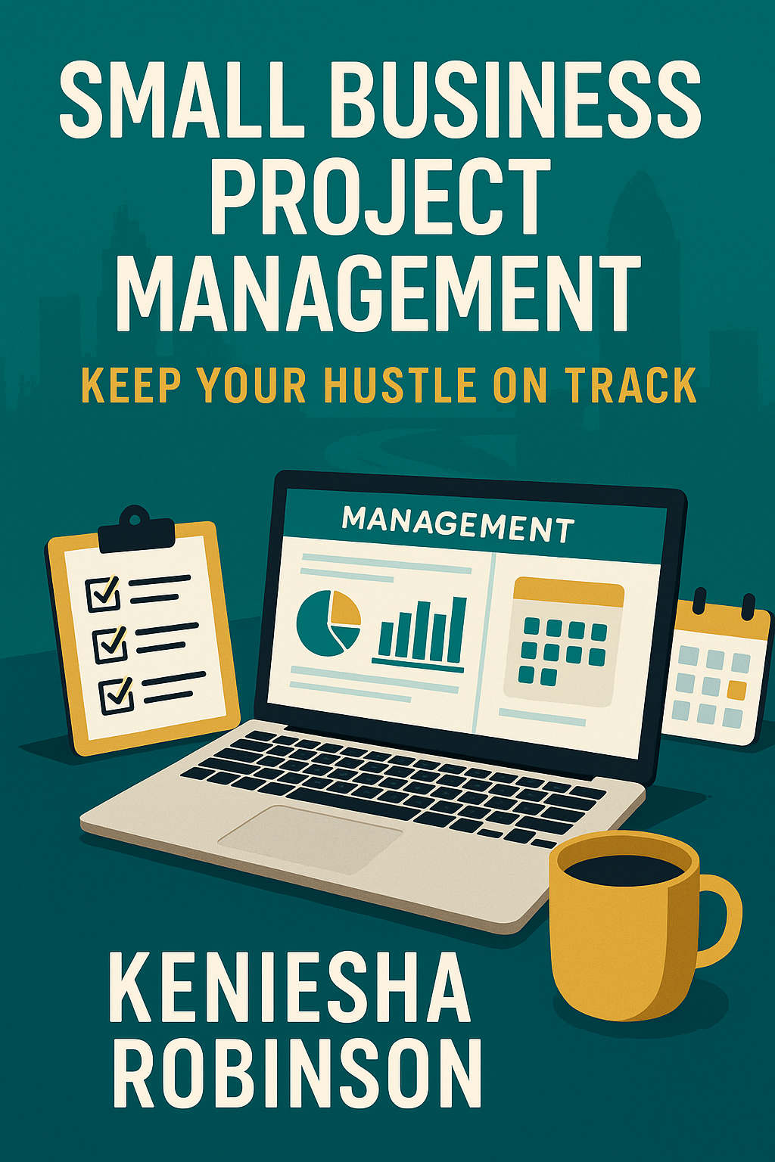

Table of Contents
- About This eBook
A quick intro to why this book exists and who it’s for.
- Why Project Management Matters for Small Business
Understand the real benefits of organizing your hustle.
- Laying the Foundation
Set clear goals, a workable budget, and realistic timelines.
- Planning Like a Pro
Learn the five core phases of project management and how to apply them.
- Managing Vendors and Contractors
Communicate expectations, timelines, and keep things professional.
- Staying on Track – Tools & Templates
Use digital tools and provided templates to keep your momentum.
- Hustler Hurdles & How to Overcome Them
Solutions for burnout, distraction, and juggling too many hats.
- Managing Your Energy, Not Just Time
Work smarter by syncing your workflow with your energy levels.
- Project Wrap-Up – Reflect & Repeat
How to evaluate what worked, celebrate wins, and apply lessons learned.
- Templates & Breakdown
Quick-access format tools like:

- Weekly Hustle Tracker
- SMART Goals Worksheet
- Vendor Checklist

Small Business Project Management: Keep Your Hustle on Track

About This eBook
This guide is for entrepreneurs, side-hustlers, and small business owners trying to manage a million moving pieces-with no formal project management training. Whether you're launching a product, running an e-commerce brand, or starting from scratch while raising kids or working full-time, this eBook gives you practical tools to keep your hustle organized, on budget, and moving forward.

Why Project Management Matters for Small Business
Project management ensures you stay focused, meet your deadlines, and manage your limited resources. It helps small businesses avoid the common pitfalls of unfinished projects, wasted money, and burnout.

Laying the Foundation
Set SMART goals, define your budget, and map out your timeline. This creates the blueprint for your project.
Break your goal into manageable phases like research, development, and launch.

Planning Like a Pro
Use five phases: Initiate, Plan, Execute, Monitor, and Close. Each phase ensures your project is properly guided and completed with clarity.

Managing Vendors and Contractors
Clearly define expectations, timelines, and deliverables. Always have contracts in place and maintain professional communication throughout the project.

Staying on Track - Tools & Templates
Use tools like Trello, Google Sheets, and Clockify. Create a Weekly Hustle Tracker to keep tabs on your
Small Business Project Management: Keep Your Hustle on Track
progress and stay organized.

Hustler Hurdles & How to Overcome Them
Learn how to manage solo workload, stay motivated, and balance business with personal responsibilities using power hours and hustle pockets.

Managing Your Energy, Not Just Time
Optimize your work schedule around your energy levels. Include time for self-care and recognize when to delegate or take breaks.

Project Wrap-Up - Reflect & Repeat
Evaluate what worked, what didn't, and how you can improve. Apply lessons learned to future projects for ongoing improvement.

Templates & Breakdown
Included are worksheets and templates like the Weekly Hustle Tracker, SMART Goals Worksheet, and
Vendor Checklist to help you implement what you've learned.

📋 1.

Weekly Hustle Tracker
Task | Owner | Start Date | Due Date | Status | Notes
Example: Product shoot | Me | 06/10/2025 | 06/12/2025 | In Progress | Waiting on photographer

🎯 2.

SMART Goals Worksheet
SMART Element | Description/Details
Specific | What exactly do you want to accomplish?
Measurable | How will you measure success?
Achievable | Is it realistic given your resources/time?
Relevant | How does this goal align with your business?
Time-bound | What is the deadline for this goal?

📑 3.

Vendor Management Checklist
Vendor Name | Service Provided | Contract Signed (Y/N) | Payment Terms | Deadline | Contact Info
Example: Print Co. | Product packaging | Y | 50% upfront | 06/20/2025 | info@printco.com

⏱️ 4.

Time Tracker Sheet
Date | Task | Start Time | End Time | Total Time (hrs) | Notes
06/10/2025 | Social media planning | 9:00 AM | 10:30 AM. | 1.5 | Scheduled 3 posts

